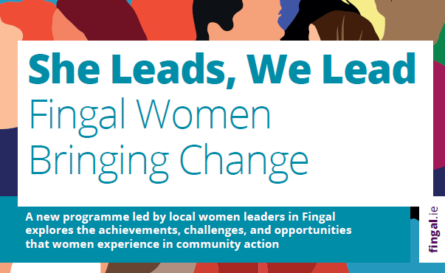

women’s leadership programme

an initiative of the Fingal County Council community development office

about this programme

This practical leadership programme introduces women in Fingal to the skills, resources and approaches already successful in the local context, and supports them in the early development of leadership activities.
Over 8 weeks, we will explore the achievements, challenges and opportunities that women experience when involved in community action.
You will learn the skills, tools and methods to make you more effective in developing and leading on community action and representations.
The combination of training and mentoring with successful local women leaders will support you to transfer your knowledge into practice while undertaking the course. You will receive ongoing support to develop your own ideas.
You will understand how to leverage the power of diversity in our communities, gaining from the success and sustainability power of diverse teams.

who is the programme for?

This programme is aimed at women in Fingal who:
- Would like to make a change in their communities through collective action
- May not typically see themselves as leaders due to gender and/or background
- Would like to develop their ideas for change, their message about the change needed and their strategy for action
- Would like to learn from experienced local women exercising their own leadership skills
- Would like to meet and work with others in the Fingal area

Meet the leader-tutors

Our Leader-Tutors are 5 women well known in Fingal for driving social change. They are each well established in advocacy, organisation and representation work, and have been instrumental in the design of this programme.
Ayodele Yusuf, of Balbriggan Integration Forum
Bridie O’Reilly of the Fingal Older People’s Council
Catherine Joyce of Blanchardstown Traveller Development Group
Geraldine Rooney, of the Fingal PPN and Centre for Independent Living Blanchardstown
Shelly Gaynor, of the Independent Living Movement Ireland
The Leader-Tutors will bring you through the programme with the support of Programme Coordinator Lucy Michael, who has taught leadership courses for more than a decade, sharing their own experiences and knowledge about leadership in Fingal with you.
We will also have guest speakers in to provide expert advice on key areas, such as working with local media.
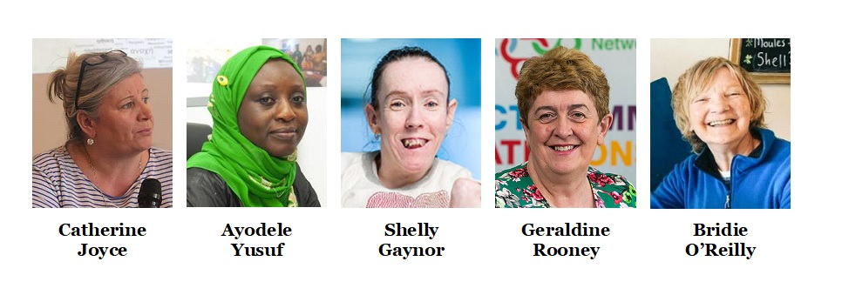
In 2021, Fingal County Council Community Development Team organized an International Women’s Day event showcasing local womens’ leadership, and featuring these 5 women leading on social issues of key interest for community development in Fingal. These conversations explored the achievements, challenges and opportunities that women experience when involved in community action. The interviews highlighted the diversity of leaders in the area, and the range of skills, resources and approaches which are used by women in successful community leadership. You can view the videos online at https://www.fingal.ie/IWD2021communityleadership

dates

The programme will be delivered on Monday nights, 7-9pm, in person at Mountview Community Centre
Monday 15 November
Monday 22 November
Monday 29 November
Monday 6 December
Monday 13 December
Monday 10 January
Monday 17 January
Monday 24 January

Outcomes

Each participant will take away:
- A personal development plan for their leadership activities
- Tools, frameworks, and practices to help navigate campaigns and representation, and to further their ability to lead, negotiate and influence with impact.
- A self-reflective understanding of and confidence in their unique leadership style and strengths.
- A clear set of messages about their values and purpose, and knowledge about how to develop those in future
- Skills in writing campaign plans, developing and delivering communications for local media, and engaging with political representatives and organisational leaders.
- A local network of like-minded women interested in community change and collective action.

Programme outline

1 Defining the problem – analysing what’s needed and what you can do
This session introduces participants to using publicly available information about the local community to define and frame the issue they want to address, identify key problems for priority action, recognise groups who share a common interest in the issue, and pinpoint key barriers. We also look at how issues can overlap, and how to find common ground while keeping your focus.
2 Working with others
Creating positive change means working with people we already know, and people we do not and who may not share our values, expectations or views. We will explore how communities can be developed from within, how power affects change, and the range of community development strategies we can draw on to brings others with us. We learn the role of cultural awareness in bringing people together and creating shared goals. This session includes group work and facilitation skills. Participants will learn to create and host inclusive action-oriented discussions, understand group dynamics, and explore some group work techniques.
3 Who’s in charge here?
Women are often reluctant to describe ourselves as ‘leaders’, and this session directly addresses the question whether there are leadership types and strategies which better suit women leaders. We explore the purpose of leadership, the forms of leadership that work in local community action, and the principles to consider when choosing a strategy. We particularly focus on problem-solving leadership and leadership change. Participants can critically assess their personal strengths, characteristics and skills to understand their choices in leadership style.
4 Share the load
Leadership is much more about the group which experiences being led, than about the person who occupies leader positions. How do you create a group that will stick together, address obstacles collectively and positively, and create an organisational structure (however small) that encourages responsibility-taking, shared development of goals and strategies, and acts supportively towards one another? In this session, we explore different forms of followership, collaboration and cooperation as ways of driving group success.
5 Get the message
In this session, we look at how we can effectively communicate our vision for change, create a climate of trust, empower those we work with, and ensure that our actions authentically reflect the shared goals of our growing group. Messages about our goals are both internal – to people we work with – and external – to others in the community and particularly to those who have the tools or power to help introduce the changes we want. This session also introduces practical skills of writing campaign texts, working with local media, becoming recognisable in our message, and adapting messages for different audiences (including social media).

6 Opening closed doors
Our trainers will lead participants through a series of case studies and facilitate participants to reflect on their own experiences of addressing institutional power. Grassroots leadership is often about addressing issues of inequality, discrimination, and the need for community empowerment. We will look at how grassroots campaign can use tried-and-tested techniques for raising awareness of a problem, targeting key stakeholder and institutions, and creating spaces of discussion and negotiation which address imbalances of power.
7 Lifelong learning and leadership
In this session, we reflect on the role of continuous development in social change, and how leaders can keep developing their skills to keep pace with their growing experience of action for change. How can you keep your group developing too? We use a series of resources created especially for this course for tracking progress on shared goals, adapting goals to reflect our values, and building on successes. Participants will progress their action plan with a future-looking assessment, and create a personal development plan for their leadership.
8 Presentation Night
Participants will present their portfolios to an invited group of local organisations and leaders.

